My insights -

**1)** Certain account types (acct_type) have a higher risk of bad credit

acct_type 55 has 11% bad credit rate (although the number of such accounts is small (17)

Among the larger accounts, acct_type 6 has a bad credit rate of 4%. This is marginally higher than the rate for acct_type 4 at 3.7%, which happens to be the lowest.

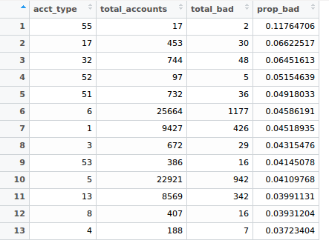

acct_type 55 is the Business Non-Funded Credit Facility – General category, per the documentation. If this is a under low-count but high-value category, then it must be given top priority.

**2)** Accounts opened in the years 2003, 2007 and 2016 show a particularly high rate of bad credit

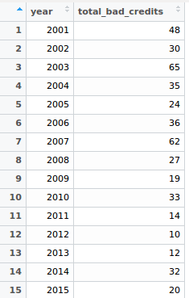

There are also dates for dt_opened that in the future, some even far into the future (between 2019-2030). I was unable to make sense of that.

**3)** The mean number of enquiries made on customers with both good and bad credit is about **17**.

If we take the top 10 customers of each category, then the ones with good credit have enquiries made about them **195** times.

The top 10 with bad credit have an average of about **106** enquiries on them.   
  
These people need to be kept on watch more.

**4)** The highest number of bad credits are associated with Individual accounts (6275), followed by Joint accounts (235)

The rates of bad credit per ownership type are fairly similar.

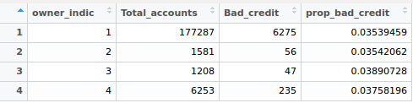

**5)** Going by payment frequency, those who make payments weekly are far less likely to have bad credit than those than pay monthy (1.6% vs 3.2% respectively)

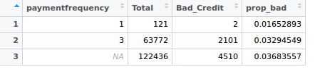

**Feature I have generated**

**(These include your suggestions and my own features)**

mean_paymenthistory_avg_dpd_0_20_bucket

last_365day_enquiries

last_90day_enquiries

mean_diff_last_payment_opened_dt

mean_diff_open_enquiry_dt

num_of_times_overdue

payment_history_mean_length

Ratio_currbalance_creditlimit

total_enquiries

total_secured

perc_secured

utilisation_trend

avg_diff_payment

median_high_credit

median_credit_limit

median_cash_limit

mean_rateofinterest

median_actualpaymentamount

median_enq_amtt